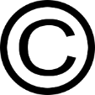
Plagiarism and Copyright Organizer
Image Source: ClipArtBest

Plagiarism
Definition | Examples | How It Affects My Life
Citation(s)

Copyright
Definition | Laws (Fair Use, Public Domain) | How It Affects My Life
Citation(s)
Visit Noodle Tools for help with MLA citations.
Name(s):

